Alfa AP1121U 802.11n AP/Router- Linux to Pineapple

Converting to Wifi Pineapple with a Serial Developer Kit-

**Materials:**

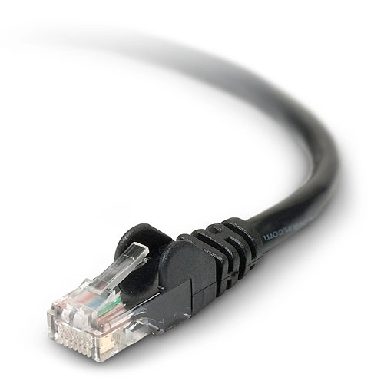

[**Alfa Router**](http://hackerwarehouse.com/) [**Serial Developer Kit for Hornet UB**](http://www.data-alliance.net/servlet/-strse-710/Developer-Kit-for-Hornet-dsh-UB/Detail)**Ethernet Cable Internet Connection**

**Downloads and Prep work:**

**Download:**

Mar 4 Version 2.8.1 found[**here**](https://wifipineapple.com/index.php?downloads&downloadUpgrade=2.8.1)

**Change Network Settings:**

**Change from DHCP to Static IP Address:**

**From the GUI:**

1. Click the up and down arrow or (network icon) on the top bar of the desktop
2. Click Edit Connections….
3. Click Edit on the Wired Connection
4. Change tab to IPv4 Settings
5. Click Add
6. Address: 192.168.2.11 | Netmask 255.255.255.0 | Gateway 192.168.2.1

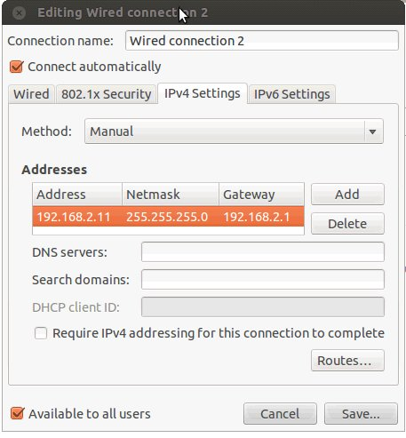

***Opening the case* :**To open the case, remove the 2 rubber feet on the bottom located at the USB port side. After removing the caps you will find two screws, unscrew them. The case is now opened!

**Connect your Ethernet Cable to the PoE LAN port on the Alfa Router and connect the other end to your network card**

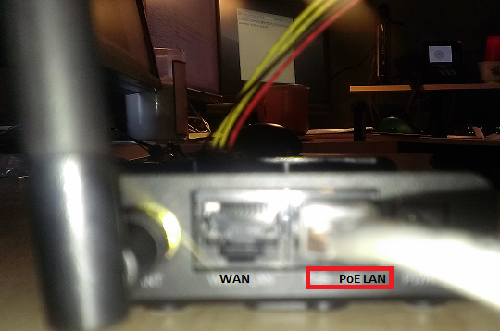

**Connect the serial converter kit to the Serial Pins and to the serial cable to your serial port on your machine**

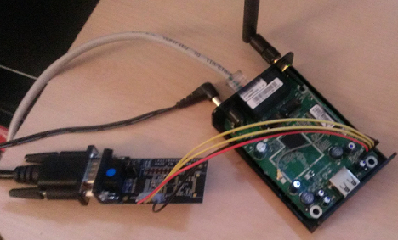

**KEEP POWER CORD UNPLUGGED until Putty session is opened**

**Putty:**

1. Open Putty.
2. Scroll down to bottom of the left side panel and click Serial
3. Change the Speed (baud) to 115200 | change Flow control to None (as seen below)
4. Scroll up on the left side panel to Session. Click Serial. Click Open.

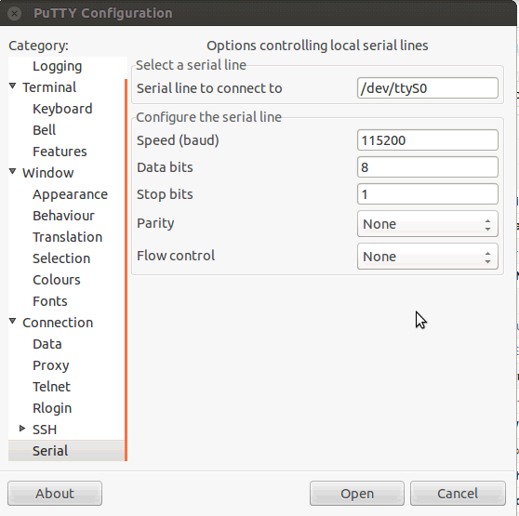

The Putty Console will prompt you to the OpenWrt console:

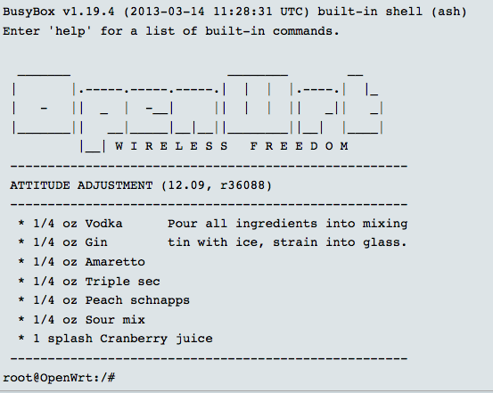

at root@OpenWrt:/# type the following:

**etc/init.d/dropbear start**

**passwd - change pwd**

On your linux machine, open the terminal. Change to the directory in which you downloaded the upgrade-2.8.1.bin file.

at the directory in which the upgrade-2.8.1.bin file is located type the following:

**scp upgrade-2.8.1.bin root@192.168.2.1:/tmp/**

move back to alfa121u putty module and change directories to /tmp/ then type the following:

**-sysupgrade -n -v /tmp/upgrade-2.8.1.bin**

do not press anything when prompted to choose one of the three operations. The pineapple firmware will load eventually.

Press any button when "...entered forwarding state"

Pineapple installed!

to connect to the pineapple console change the network settings

Address: 172.16.42.42

Netmask: 255.255.255.0

Gateway: 172.16.42.1

enter 172.15.42.1:1471 into the browser bar

user name is root

enter the same password you used to change the initial password

You will now have access to the Pineapple control Center